*Inheritance*

*Types of Inheritance.*

1. Single inheritance
2. Multilevel inheritance
3. Hierarchical inheritance
4. Multiple inheritance
5. Hybrid inheritance

*1.Single/Simple Inheritance*

In this only one super/parent class and only one sub class/child called as single/simple Inheritance.

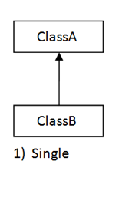

**public** **class** Bank {

**public void** getBankDetails() {

System.***out***.println("this is Bank details..");

}

}

**public** **class** SavingBank **extends** Bank {

**public void** getSavingBankDetails() {

System.***out***.println("this is saving Bank details.");

}

}

**public** **class** TestMain {

**public** **static** **void** main(String[] args) {

SavingBank savingBank = **new** SavingBank ();

savingBank.getSavingBankDetails();

savingBank.getBankDetails();

}

}

Output

this is saving Bank details.

this is Bank details..

*2.Multilevel inheritance*

It has only one base class and number of derived class called as multilevel. Or it refers to the concept of one class extending (Or inherits) more than one base class.

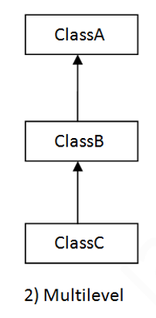

**public** **class** A {

**void** m1() {

System.***out***.println("Class A- m1 () method");

}

}

**public** **class** B **extends** A{

**void** m2() {

System.***out***.println("Class B- m2 method");

}

}

**public** **class** C **extends** B {

**void** m3() {

System.***out***.println("Class c- m3 () method");

}

**public** **static** **void** main(String[] args) {

C c= **new** C();

c.m1();

c.m2();

c.m3();

}

}

Output

Class A- m1 () method

Class B- m2 method

Class c- m3 () method

*3. multiple inheritance*

Having more than one Parent class at the same level is called multiple inheritance.

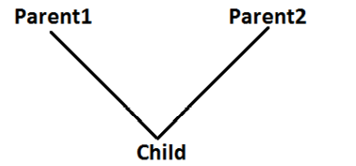

Any class can extend only one class at a time and can't extends more than one class simultaneously hence java won't provide support for multiple inheritance.

Class base has test () method and class derived has also test () method. Class test extends Base, Derived, which test method It will called, so it creates the ambiguity so that’s why multiple inheritance does not support in java.

**public** **class** A {

**void** m1() {

}

}

**public** **class** B {

**void** m1() {

}

}

**class** C **extends** A,B {

**public** **static** **void** main(String[] args) {

C c= **new** C();

c.m1();

}

}

Note- it will get the compile time error.

*4.Hierarchical inheritance*

One class is inherited by many sub classes called as.

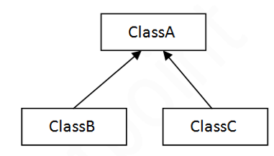

**public** **class** A {

**void** m1() {

System.***out***.println("Class A- m1 () method");

}

}

**public** **class** B **extends** A {

**void** m2() {

System.***out***.println("Class B- m2() method");

}

}

**public** **class** C **extends** A{

**void** m3() {

System.***out***.println("Class C- m3 method");

}

}

**public** **class** D {

**public** **static** **void** main(String[] args) {

B b = **new** B();

C c = **new** C();

b.m1();

b.m2();

c.m3();

}

}

Output

Class A- m1 () method

Class B- m2() method

Class C- m3 method

*5.Hybrid inheritance*

It is the combination of single and multiple inheritance. So, it is not allowed in java.